1.
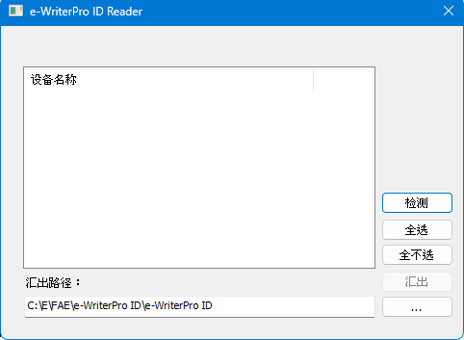
Once the user’s computer is connected to the e-WriterPro, the device can be detected and identified, allowing the system to determine whether it meets the trade-in eligibility requirements. If eligible, the relevant information (ID and manufacturing date) can be exported to a .txt file.
Notes:
- Other hardware devices (e-Writer32, e-WriterPro2, etc.) cannot be recognized.
- If the e-WriterPro being tested is faulty, detection will not be possible.

